**Guide to Installing R and RStudio**

## Before you start

Make sure that you have about 500 MB of free space on your machine. We will need this space to install both R and RStudio, and when the program installs the compressed files expand to take much more space. We will use Rstudio for the class, but Rstudio relies on R being installed first. You cannot use Rstudio without having R installed on your machine.

## Installing R

1. Go to [this website](https://cloud.r-project.org/).
2. If you have a Windows machine, click “Download R for Windows” at the top of the page.
   1. Next, click “install R for the first time”
   2. Next, click “Downlaod R 4.0.2 for Windows
   3. Your download should begin. Once the file has been downloaded, click on it: it will unpack and copy all the files to your hard drive. (If you run into any issues, consult the FAQ sections in the link above.)
3. If you have a Mac machine, click “Download R for (Mac) OS X” at the top of the page.
   1. Next, click “[R-4.0.2.pkg](https://cloud.r-project.org/bin/macosx/R-4.0.2.pkg) (notarized and signed)”
   2. Your download should begin. Once the file has been downloaded, click on it: it will unpack and copy all the files to your hard drive. (If you run into any issues, consult the FAQ sections in the link above.)

* ACCEPT the default startup options.
* YES to a Start Menu folder, and
* YES to a desktop icon and to a Quick launch icon.

R is now **installed** on your computer.

## Installing RStudio

1. Go to [this website](https://www.rstudio.com/products/rstudio/download/#download). And scroll to the section that reads “All Installers”
2. If you have a Windows machine:
   1. Click on the download link to the right of Windows 10/8/7 that reads “Rstudio-1.3.959.exe” The file download will begin.
3. If you have a Mac machine:
   1. Click on the download link to the right of macOS 10.13+ that reads “Rstudio-1.3.959.dmg” The file download will begin.
4. Once the file has been downloaded, click on it and walk through the installation process.

* YES to the question on whether you want to allow this app to make changes to your device.
* Choose Install Location: C:\Program Files\RStudio.

RStudio is now **installed** on your computer.

### Testing RStudio

1. Double-click on the RStudio icon in the Applications. A window titled “RStudio” should pop up, looking something like this:

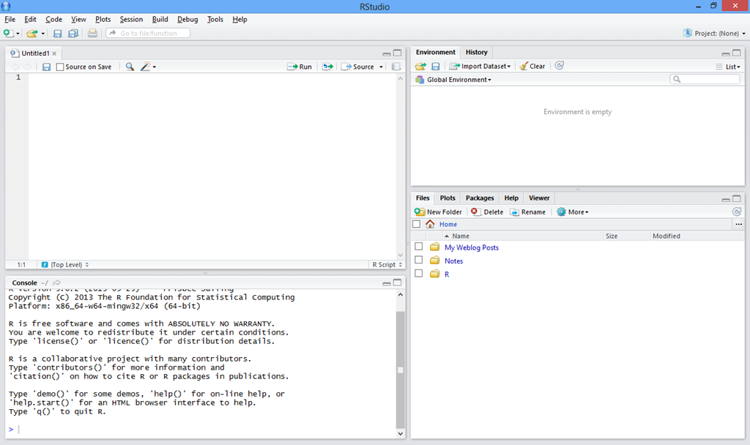

Source: [*https://slobaexpert.files.wordpress.com/2014/02/image35.png*](https://slobaexpert.files.wordpress.com/2014/02/image35.png)

## Learning R Syntax

If you want a short introduction to R before we get started with the course, check out these links:

1. <https://www.tutorialspoint.com/r/index.htm>
2. <https://rstudio.com/wp-content/uploads/2016/10/r-cheat-sheet-3.pdf>
3. <https://rstudio.com/resources/cheatsheets/>

The first link will walk you through some of the basic syntax of R. Sometimes you will be able to interact with the modules by clicking “Live Demo.” By clicking this button you’ll be brought to a new window that provides you with example code, which you can play with to see how it effects your output. The other two resources are “R cheat sheets.” These are popular among coders because they help synthesize really popular commands on different topics, like data analysis.